2018

Building challenge 2018 Assignment DESCRIPTION

The Moskow case: Zhivopisny Bridge

Introduction
Zhivopisny Bridge is a cable-stayed bridge that spans Moskva River in north-western Moscow, Russia. It is the first cable-stayed bridge in Moscow. Opened on 27 December 2007 as a part of Krasnoprenensky avenue. It is also the highest cable-stayed bridge in Europe.
Zhivopisny Bridge
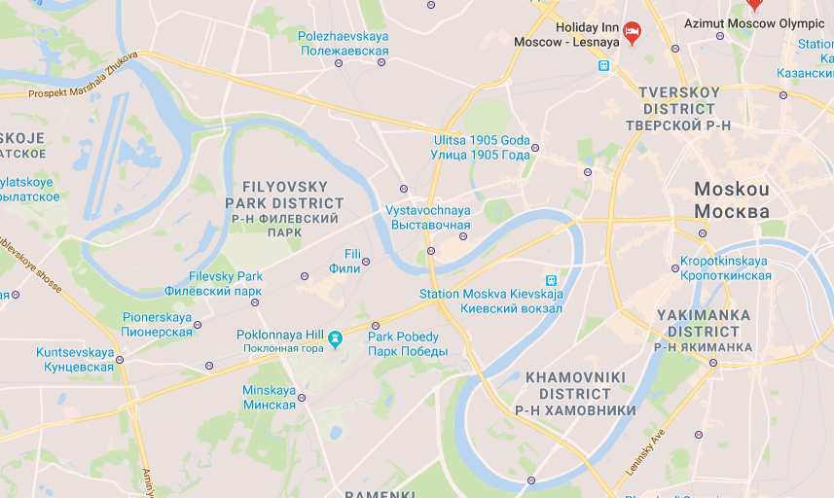
Moskwa river
Moscow City
Fig 1: map Moskow: Zhivopisny Bridge

Design and specifications

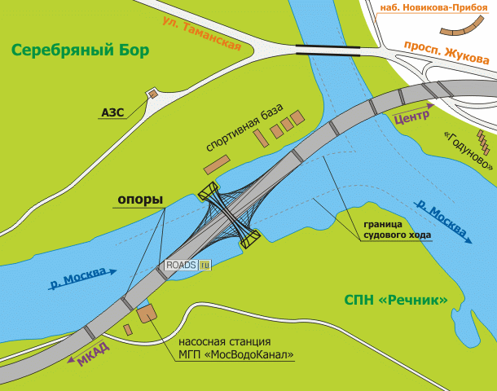
Fig2 . Designsketch Zhivopisny Bridge

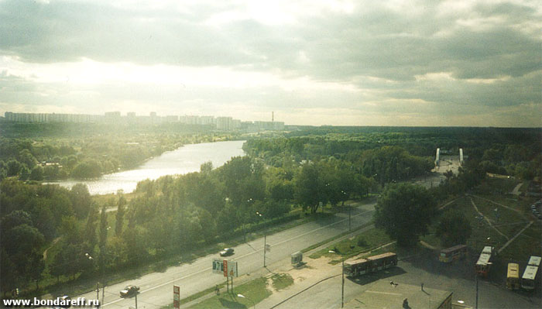
The bridge is unique in that most of its length runs along the river, not across it (see the site plan). Thus the bridge and highway it carries will bypass the protected territory of Serebryany Bor island. There are two main aspects to examine concerning of this Bridge:

1.The Bridge as architectural object

Total length of an S-shaped deck exceeds 1.5 kilometers, including a 420-meter long, 47-meter wide main section running 30 meters above and along the centerline of river Moskva. The main pylon is a 105-meter high arch across the river, carrying the weight of deck through 78 cables. Under the top of the arch, there is a disk-like structure that was intended to house a restaurant. The restaurant project is now abandoned due to fire safety concerns and lack of investment. Cars appeared on the Zhivopisny Bridge over the Moscow river in 2007, but the dome hanging under the arch has not been used. They wanted to use it as an observation deck first, then – as a restaurant, finally it was decided to make a registry office there. This “egg” will be used as a registry office.

Then along came the civil registry office of the city of Moscow with the announcement that the “flying saucer” looking deck would be completed and turned into a “wedding palace” (Дворец Бракосочетания) known by the acronym ЗАГС (ZAGS) where state ceremonies and registration of marriages take place. After structural engineers had fixed the defects in the design, hopefully.
The opening was delayed for a couple of years however but last month city officials and head of the Moscow ЗАГС (Civil Registry Office), Irina Muraveva, said that the residents of Moscow will be able to marry in the glass pod by the end of this year, with ceremonies literally under the arch of the scenic bridge while hanging above the Moscow River and the Serebryanyy Bor below.
For now, engineers are putting the final lifts (elevators) into place. This wedding palace will have two wedding spaces, inside the pod and the other on the observation deck overlooking the river. Having a wedding ceremony 105 metres above the everyday fray below will allow couples to enjoy “a match made in heaven. “ But at this time “The Egg” is still not used.

2. The adjacent territory to the Bridge

Zhivopisny Bridge is located in north – western part of Moscow city and appears to be one of the most picturesque sightseeing that attracts the tourist flow.
On the right hand there is the recreational territory of Serebryanyy Bor , sport area with Grebnoy canal. Public Park of Wonders located in the radius of 1 km from the exit to the Bridge.
On the left hand there are sport facility and a territory of public use that now is free.
From point of view of urban planning it is necessary to develop not only the Bridge but also the adjacent territories to create one and indivisible environment as for resident and guests of the city.

Building process in time
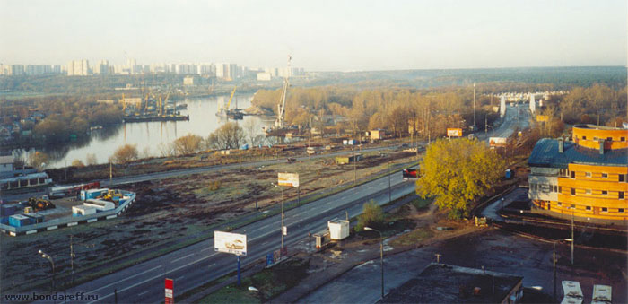 | 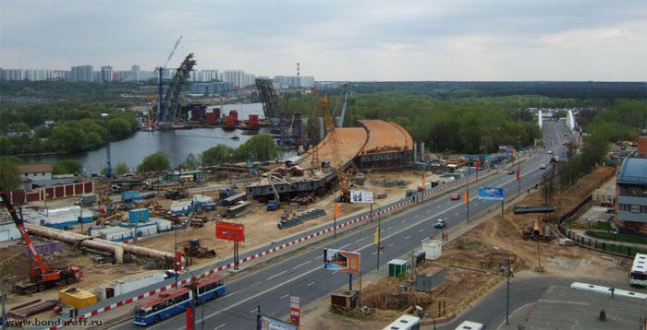
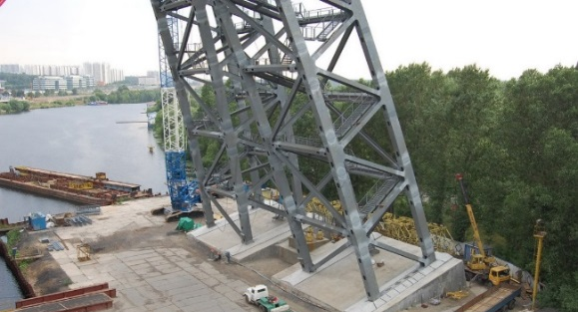 | 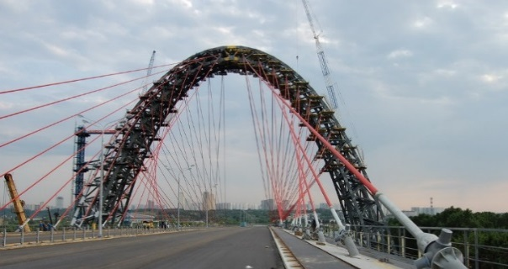
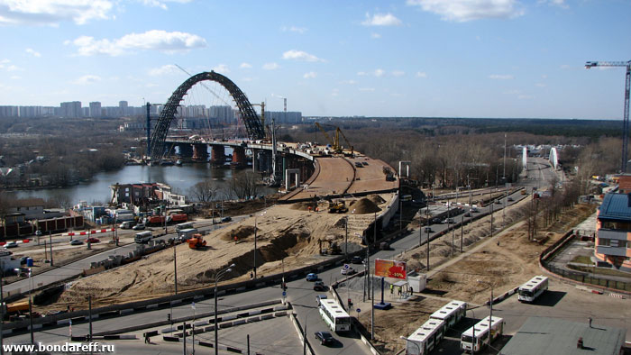 | 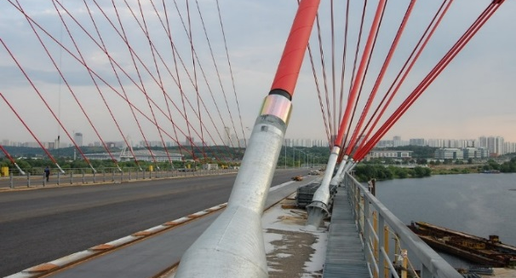
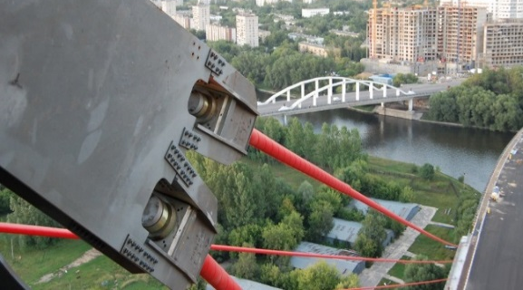 | 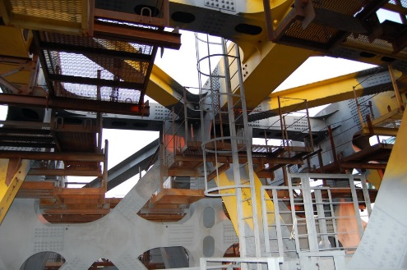
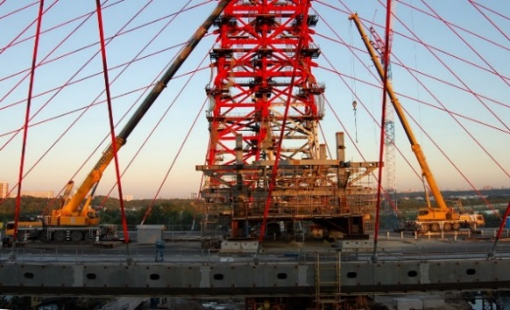 | 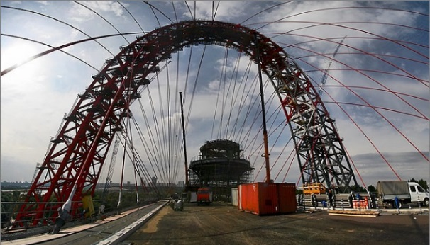
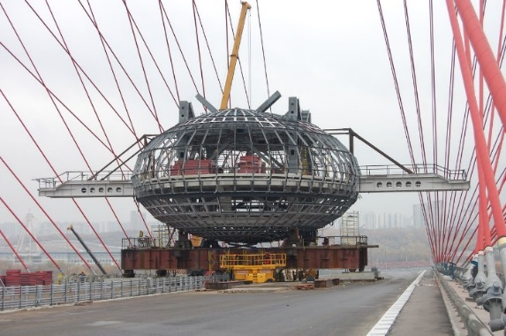 | 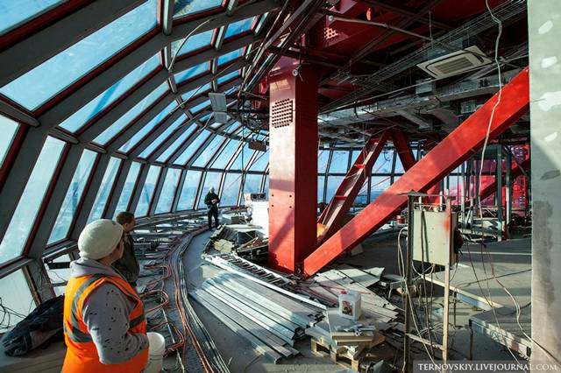
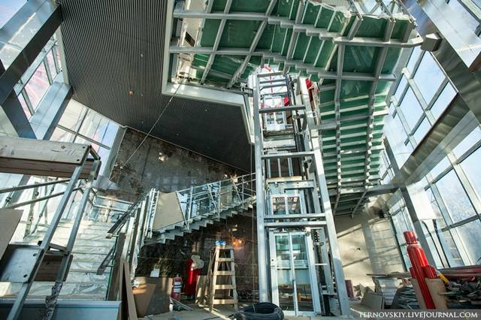 | 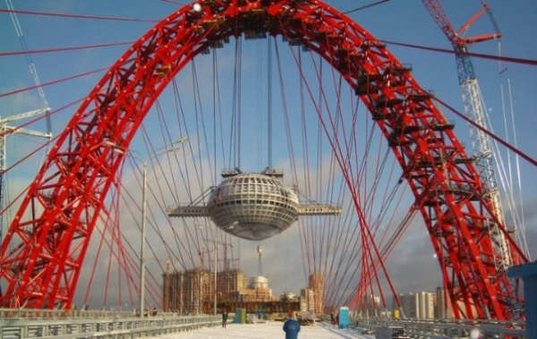
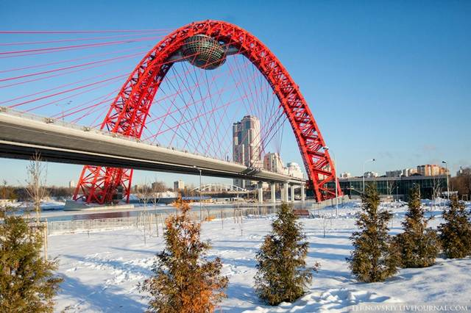 | 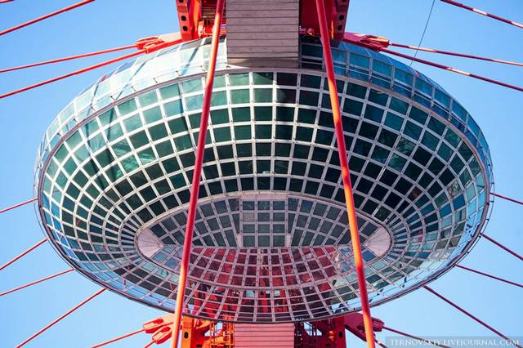

How it will be done & what do we expect?
You will work in teams of 8 or 10 students of different disciplines and need to divide the tasks accordingly, in order to use everyone’s specialization. The different project teams are going to work on the assignment and will eventually deliver the results of their work and proposals to a jury at the end of the building challenge program. The results of the project work should be presented in for example a PowerPoint or Prezi presentation or any form that seems suitable. Project teams will be judged among others on the quality of the work done on a number of products within a coherent context (See the different project steps above for more details) and the list below for some of the important items (not exhaustive, teams may add different ones) that should be involved in the final analysis and presentation:
- Aesthetic quality of architectural, construction and urban planning solutions.
- Quality of Urban environment: comfort ability, safety, human-oriented solutions, inclusive environment.
- Multifunctional territory planning and organization.
- Sustainability of the Project solution.
- Financial feasibility.
- Constructive feasibility: an overall analysis of the building’s construction feasibility, within the existing and new environment.
- Functional quality: a qualitative assessment of the solutions offered, whether and in how far these follow the functional requirements of the client.
- Energy neutrality: assessment of the energy use of the building.
- An environment plan: a vision for the immediate environment of the assignment object.
- Environmental quality: This aspect is essential. Concrete solutions are needed to help create a better indoor climate and to reduce CO2 emissions.

The requirements to the presentation
Timing – 15 minutes + 10 minutes for answering to questions
Presentation shall include but no limited to:
- Team name, project name
- Slides about each member of the team ( photo, name, university, what tasks he/she does). 1 slide = 1 person
- Main aims of the Project
- Explanation of the choice of the function of the object and the territory, its technical and economic indicators
- Conception of Project development
- Characteristics of the architecture features
- Urban aspects (situational plan, transportation scheme)
- The images of design solutions
- Interior design samples by functional zones
- Economic justification ( investments, opex, income and payback period)
- Benefit analysis for stakeholders.

About the organization
The building challenge is an initiative of a number of Universities in Moscow and Saxion University of Applied Sciences in Enschede (The Netherlands). The general idea is to set up a creative environment for students to work together in a multidisciplinary team, in order to design cutting edge and state of the art solutions based on a real estate development challenge. Therefore, besides students of the Moscow universities NNGASU, B & D and MArchi, also a number of Dutch building engineering an Civil Engineering students will join this Moscow “”Zhivopisny Bridge” challenge, to give students the opportunity to work in real international and intercultural teams. This means that besides learning in practice about construction and planning related issues, students will also learn about intercultural aspects.
The building challenge is supported by the Dutch NESO Russia Institute in Moscow.

Tutors
From NOIFA: Denis Gavrikov mail: fachwerk.fachwerk@gmail.com phone: 007916 319 86 86

The assignment for Bridge Project: for engineers and architects

The object of development
As you see within the past years there where several attempts to create a feasible function for “The Egg”. Time for a new approach and bring the challenge to students of different background and interest. The assignment is not limited to the Egg itself. We invite you too look beyond borders and include design, logistics, functions, social need, financiale feasabilty, sustainability etc. within your vision.

The assignment
The assignment for this architectural object is to develop one or more new functions for The egg and it’s direct environment.
To help you with the development of your ideas, please follow the steps below.

Step 1
Think about a function for the Egg. What function would you propose, Residential or Business? Investigate what other functions are around and which things in this area maybe still missing or could complement existing functions. Please carefully explain and motivate why the function you choose is the best choice.

Step 2
Develop a plan for “the Egg”. Please do at least some market research, in order to solidify your assumptions. Do this by finding other sources of information, for example archives or (expert) interviews (make sure to document your findings properly!). The plan that you develop in this stage must provide proof that your idea is feasible.

Step 3
Develop a plan for renovating “The Egg”. If necessary, do not hesitate to use the historical pictures and drawings handed out to you to find out how the building looked like in the past. Prepare a 3D drawing of the outside of the building. Based on the function for the building that you decided upon in Step 2, develop a floor plan suitable for it. There is no legal monument status for “The Egg”.

Step 4
Develop a financial plan, based on the functions of the building. Use the 20 year total cost of ownership method for selecting the most suitable scenario in terms of which building materials to use in relation to later maintenance costs. Your design has to comply with the highest expectations of sustainability in technical sense and energy use.

The assignment for adjacent territory to the Bridge: for urban planners

The object of development
Zhivopisny Bridge is the central focus of adjacent territories including:
1 - adjacent territory to Grebnoy Canal sport area;  2 – territory of Park of Wonders (Парк Чудес);  3 - public functional zone. | Fig.1

Initial data
To develop this territory you can use the following information:
- Territory map will help you to explore the territory
Fig.2 Territory map

- Moscow Masterplan 2025 will give you official information about territory use. Functional zoning of adjacent territories is presented on fig.2
Link:

Fig.3 Functional zoning of the territory

- Layout of the territory is in your Dropbox. You can use it to make your projects.
Fig.4 Layout of the territory

The assignment

The assignment for this part of the project is to develop Conception of Zhivopisny Bridge and adjacent territory development.
The goals of the Conception Projects are:
- To design your own planning and spatial solution of the territory;
- To project transport service plan for the territory;
- To project environmental protection activities;
- To make visualization of your Project;
- To analyze strengths and weaknesses of the Project.
To help you with the development of your ideas, please follow the steps below.

Step 1
Make your survey of the territory, analyze all initial data and define the borders of the conception project.

Step 2
Think about functions for the territory and define where and in what way they will be organized. Carefully explain how your suggestions integrate in existing situation.

Step 3
Define the Conception Idea of Your Project. Project your planning and spatial solution of the territory including all needed layouts. Explain if your solution addressed to the sustainable development of the territory. Define strengths and weaknesses of your Project.

